*Title:*

Meta-fibres: Optical fibres with meta-surfaces for hair-thin imaging devices

*Abstract:*

Optical endoscopes are widely used in medicine to identify early-stage cancers in accessible parts of the body, such as the gastrointestinal tract, enabling early treatment and better patient outcomes. However, the next generation of endoscopes must overcome two key challenges to have a truly transformative impact. The first is size: hair-thin endoscopes would vastly expand the range of the body that can be examined in detail with minimal invasiveness, e.g. inside organs such as the pancreas via a needle, or inside tiny blood capillaries. The second is contrast: when imaging large regions it is difficult to identify subtle tissue changes indicative of early cancer. To overcome this, we have been developing a new type of endoscope that produces images through optical fibres: flexible hair-thin pieces of glass. This is achieved by combining two key technologies: holographic control of light in fibres and nanostructured optical metasurfaces. Together, these two technologies enable the implementation of advanced microscopy modalities in a hair-thin form factor. This makes high-contrast optical imaging deep inside the body possible. In this talk I will introduce the fundamentals of our fibre imaging technique and show how it can achieve quantitative phase and polarimetric imaging of tissue. I will then show how using nano-structured optical metasurfaces and computational optics techniques (including AI) will enable future clinical translation of this technology.

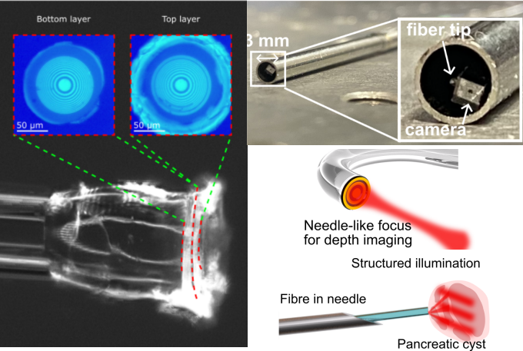

*Bio:*

George Gordon is an Associate Professor and UKRI Future Leaders Fellow in the Department of Electrical and Electronic Engineering at the University of Nottingham. He leads the OPTIMlab group, a team of 7 researchers working on optics, photonics and medical imaging, specifically developing new types of optical endoscopes that improve detection of diseases such as cancer. His related research interests also include digital holographic imaging and displays, artificial intelligence, nano-structured optical metasurfaces and clinical studies. Prior to this role, George was a post-doctoral researcher at the University of Cambridge where he built a fully holographic fibre endoscope and developed low-cost imaging techniques to improve early cancer detection. He received his Ph.D. in 2013 from the University of Cambridge on the topic of Wireless and Optical Telecommunications. Originally from New Zealand, George completed his undergraduate degree in Electrical and Electronic Engineering at the University of Auckland. He is an author of more than 30 peer-reviewed journal publications, on topics ranging from optical fibres to nanotechnology to reinforcement learning.