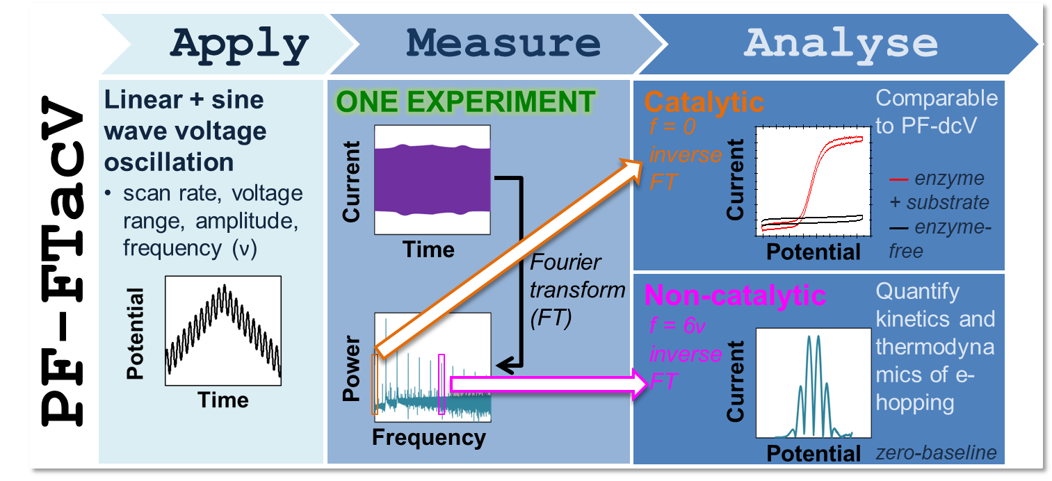
Figure 1. Overview of the technique of protein film Fourier transform alternating current voltammetry, PF-FTacV.

