New Electrochemical Methods for Understanding Biological Redox Chemistry
Dr Alison Parkin, University of York
Biology produces many inspirational catalysts that ‘activate’ small, inert, molecules such as protons, N₂ and H₂O via redox chemistry catalysed at transition metal active sites. Such enzymes are used in novel clean-energy technologies such as enzyme fuel cells and solar water-splitting devices. The Parkin group is developing protein film Fourier Transform Voltammetry (PF-FTacV) as a tool to study these bio-catalysts in collaboration with Prof Alan Bond (Monash).^{1,2} This talk will showcase recent work carried out on [NiFe]-hydrogenases. Although an “O₂-tolerant” subset of enzymes offer the tantalizing ability to remain catalytically active at oxidizing H₂ in air, they are unfortunately very poor H₂ production (H⁺ reduction, 2H⁺ + 2e⁻ H₂) catalysts.³ By combining electrochemistry, molecular biology and structural studies we have been able to prove that it is the electron-transfer relay of iron-sulfur centres, not the active site ligands, which play a vital role in controlling O₂ inhibition and catalytic bias.^{4,5} We are now exploring why this happens using PF-FTacV and unpublished results will demonstrate our progress in probing electron transfer centres that are invisible via all previous experiments using electron paramagnetic resonance and “traditional” direct current protein film voltammetry. New advances in electrode surface modifications are also described.⁶
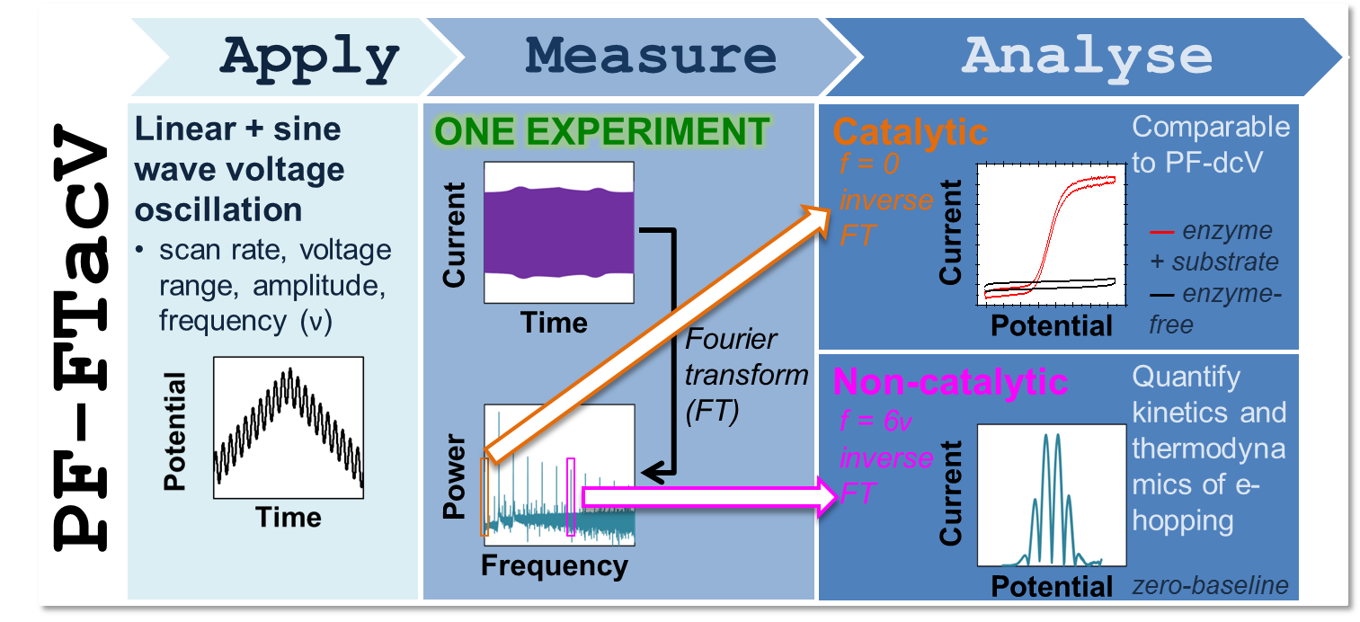
Figure 1. Overview of the technique of protein film Fourier transform alternating current voltammetry, PF-FTacV.

- Adamson H, Robinson M, Bond PS, Soboh B, Gillow K, Simonov AN, Elton DM, Bond AM, Sawers RG, Gavaghan DJ, Parkin A. Anal Chem. 2016 Dec 28. doi: 10.1021/acs.analchem.6b03589. [Epub ahead of print]
- Adamson H, Simonov AN, Kierzek M, Rothery RA, Weiner JH, Bond AM, Parkin A. Proc Natl Acad Sci U S A. 2015 Nov 24;112(47):14506-11. doi: 10.1073/pnas.1516869112.
- Parkin A. Met Ions Life Sci. 2014;14:99-124. doi: 10.1007/978-94-017-9269-1_5.
- Flanagan LA, Wright JJ, Roessler MM, Moir JW, Parkin A. Chem Commun (Camb). 2016 Jul 12;52(58):9133-6. doi: 10.1039/c6cc00515b.
- Bowman L, Balbach J, Walton J, Sargent F, Parkin A. J Biol Inorg Chem. 2016 Oct;21(7):865-73. doi: 10.1007/s00775-016-1385-4.
- Juan-Colás J, Parkin A, Dunn KE, Scullion MG, Krauss TF, Johnson SD. Nat Commun. 2016 Sep 14;7:12769. doi: 10.1038/ncomms12769.

