Phosphorus in Low Coordination: Recent Developments in the Chemistry of Phosphabenzenes
Christian Müller
Institute of Chemistry and Biochemistry
Freie Universität Berlin
Germany
http://www.bcp.fu-berlin.de/ak-mueller
c.mueller@fu-berlin.de

Low-coordinate phosphorus(III) compounds have recently re-gained noticeable interest as the very peculiar stereoelectronic and coordination properties of such λ³σ²-species differ significantly from classical trivalent λ³σ³-phosphanes. These special characteristics can lead to interesting effects in more applied research fields, such as homogeneous catalysis and material science.
We recently found a facile synthetic access to the Si(CH₃)₃-substituted phosphabenzene (phosphinine) II, from which the parent compound C₅H₅P (I) can be prepared by means of a protodesilylation reaction (Figure 1).^{[1]} We noticed that the Si(CH₃)₃-group in β-position of the phosphorus atom has a significant influence on the electronic properties of II, which results in a distinct reactivity of this heterocycle towards certain main group elements and main group compounds.
This lecture will focus on the design and preparation of novel, functionalized phosphinines (Figure 1), the higher homologs of pyridines. Special emphasis will be paid to the modification of their electronic properties, their coordination chemistry and reactivity.^{[2-5]}

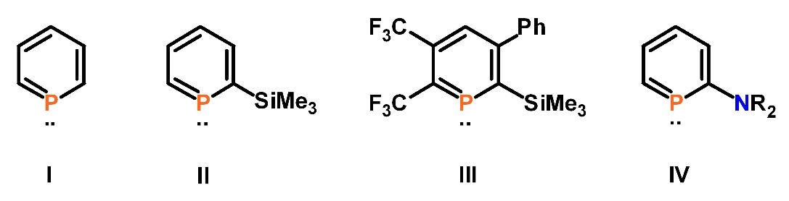
Figure 1. Parent phosphinine I and selected examples of functionalized phosphinines II-IV.

[1] M. H. Habicht, F. Wossidlo, T. Bens, E. A. Pidko, C. Müller, Chem. Eur. J. 2018, 24, 944.
[2] M. H. Habicht, F. Wossidlo, M. Weber, C. Müller, Chem. Eur. J. 2016, 22, 12877.
[3] S. Giese, D. Buzsáki, L. Nyulászi, C. Müller, Chem. Commun. 2019, 55, 13812.
[4] J. Leitl, M. Marquardt, P. Coburger, D. J. Scott, V. Streitferdt, R. M. Gschwind, C. Müller, R. Wolf, Angew. Chem. Int. Ed. 2019, 58, 15407
[5] G. Pfeifer, F. Chahdoura, M. Papke, M. Weber, R. Szűcs, B. Geffroy, D. Tondelier, L. Nyulászi, M. Hissler, C. Müller, Chem. Eur. J. 2020, 26, 10534.

