Open-shell Singlet Diradicaloids, Polyradicaloids and Covalent Organic Radical Frameworks

Our group has conducted intensive studies on open-shell singlet diradicaloids and polyradicaloids,¹ mainly including zigzag graphene fragments² and pro-aromatic quinoidal compounds.³ In addition, global aromaticity in 2D macrocyclic polyradicaloids⁴ and even 3D molecular cage⁵ was observed. Extension of the polyradicaloid system to 2D framework leads to covalent organic radical frameworks (CORFs),⁶ which demonstrated interesting magnetization depending on the topological structure and inter-radical exchange interaction.
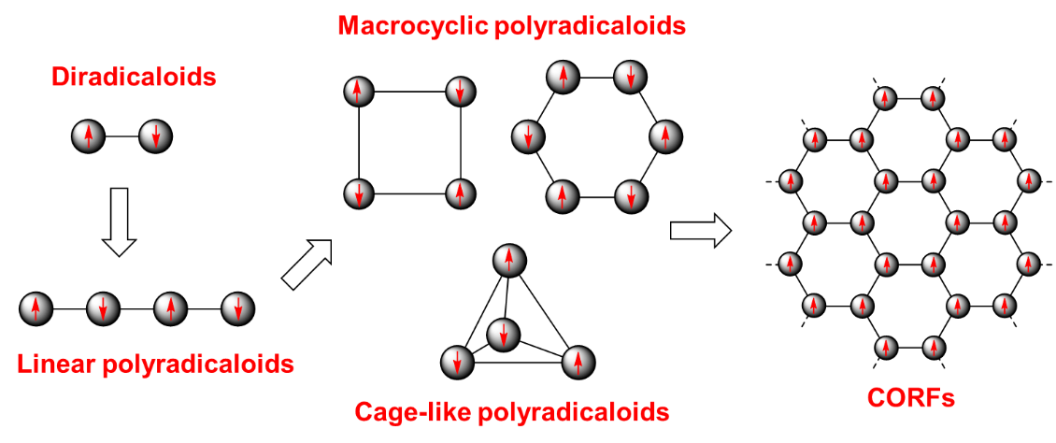
References
[1] See our reviews/accounts: (a) Z. Sun et al., Acc. Chem. Res. 2014, 47, 2582. (b) Z. Zeng et al., Chem. Soc. Rev. 2015, 44, 6578. (c) T. Y. Gopalakrishna et al., Chem. Commun. 2018, 54, 2389. (d) C. Liu et al., Acc. Chem. Res. 2019, 52, 2309. (e) W. Zeng et al., Chem 2021, 7, 358.
[2] See examples: (a) Z. Sun et al., J. Am. Chem. Soc. 2011, 133, 11896. (b) Y. Li et al., J. Am. Chem. Soc. 2012, 134, 14913. (c) Z. Sun et al., J. Am. Chem. Soc. 2013, 135, 18229. (d) R. Huang et al., J. Am. Chem. Soc. 2016, 138, 10323. (e) W. Zeng et al., Angew. Chem. Int. Ed. 2016, 55, 8816. (f) P. Hu et al., J. Am. Chem. Soc. 2016, 138, 1065. (g) W. Zeng et al., Chem 2017, 2, 81. (h) Y. Gu et al., Angew. Chem. Int. Ed. 2018, 57, 6541. (i) Y. Ni et al., Angew. Chem. Int. Ed. 2018, 57, 9697. (j) W. Zeng et al., J. Am. Chem. Soc. 2018, 140, 14054. (k) J. Su et al., Sci. Adv. 2019, 5: eaav7717. (l) Y. Zou et al., J. Am. Chem. Soc. 2019, 141, 7266. (m) J. Su et al., Nano Lett. 2021, 21, 861. (n) M. Telychko et al., Sci. Adv. 2021, 7: eabf0269.
[3] See examples: (a) Z. Zeng et al., J. Am. Chem. Soc. 2012, 134, 14513. (b) Z. Zeng et al., Angew. Chem. Int. Ed. 2013, 52, 8561. (c) Z. Zeng et al., J. Am. Chem. Soc. 2013, 135, 6363. (d) Z. Zeng et al., J. Am. Chem. Soc. 2015, 137, 8572. (e) Y. Ni et al., Angew. Chem. Int. Ed. 2016, 55, 2815. (f) H. Zhang et al., Angew. Chem. Int. Ed. 2017, 56, 13484. (g) G. Li et al., Angew. Chem. Int. Ed. 2017, 56, 5012. (h) J. Wang et al., Angew. Chem. Int. Ed. 2017, 56, 14154. (i) G. Li et al., Angew. Chem. Int. Ed. 2019, 58, 14319. (j) G. Li et al., Angew. Chem. Int. Ed. 2021, 60, DOI: 10.1002/anie.202100606.
[4] See examples: (a) S. Das et al., J. Am. Chem. Soc. 2016, 138, 7782. (b) X. Lu et al., J. Am. Chem. Soc. 2017, 139, 13173. (c) G. Li et al., Angew. Chem. Int. Ed. 2018, 57, 7166. (d) A. Rana et al., Angew. Chem. Int. Ed. 2018, 57, 13052. (e) X. Lu et al., Angew. Chem. Int. Ed. 2018, 57, 13052. (f) C. Liu et al., Chem 2018, 4, 1586. (g) X. Lu et al., J. Am. Chem. Soc. 2019, 141, 5934. (h) Y. Ni et al., Chem 2019, 5, 108. (i) Z. Li et al., J. Am. Chem. Soc. 2019, 141, 16266. (j) L. Ren et al., Angew. Chem. Int. Ed. 2020, 59, 2230. (k) Y. Ni, et al., Angew. Chem. Int. Ed. 2020, 59, 7414.
[5] See examples: (a) X. Gu et al., Angew. Chem. Int. Ed. 2017, 56, 15383. (b) Y. Ni et al., Nat. Chem. 2020, 12, 242. (c) G. Li, et al., Angew. Chem. Int. Ed. 2020, 59, 9727. (d) Y. Ni et al., J. Am. Chem. Soc. 2020, 142, 12730. (e) J. Zhu et al., J. Am. Chem. Soc. 2021, DOI: 10.1021/jacs.1c00409.
[6] See examples: (a) S. Wu et al., Angew. Chem. Int. Ed. 2018, 57, 8007. (b) H. Phan et al., Chem 2019, 5, 1223.

