Building precise molecular architectures to engineer f-element properties

David P. Mills
Department of Chemistry, The University of Manchester, Oxford Road, Manchester, M13 9PL, UK. E: david.mills@manchester.ac.uk; W: millsgroup@weebly.com; T: @millsgroupchem.
The complexity and richness of synthetic f-element chemistry has attracted increasing attention in recent years. This interest is stimulated jointly by scientific curiosity of a relatively unexplored field and the myriad applications that these elements have found in diverse areas such as organic synthesis, materials science and nuclear fuel cycles.¹ Our research focuses on stabilising f-element complexes with unusual coordination geometries and/or oxidation states, which can provide enhanced reactivity and unique physical properties.¹ We mainly utilise bulky bis(silyl)amides and cyclopentadienyls as supporting ligands to stabilise these unusual f-element motifs. Here we will present some recent highlights of this work, such as the first near-linear f-element complexes (1),² the first measurements of actinide covalency by pulsed EPR spectroscopy on the Th(III) complex (2)³ and isolated f-block metallocenium cations (3), which provided record magnetic hysteresis temperatures for the dysprosium analogue in 2017.⁴
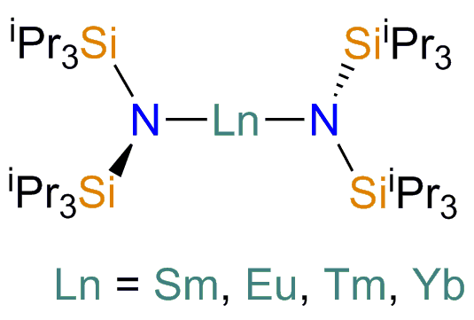 (1) (2) (3)

References:
1. (a) Lanthanide and Actinide Chemistry, S. Cotton, John Wiley & Sons Ltd, 2005.
2. (a) C. A. P. Goodwin, N. F. Chilton, G. F. Vettese, E. Moreno Pineda, I. F. Crowe, J. W. Ziller, W. J. Evans and D. P. Mills, Inorg. Chem., 2016, 55, 10057; (b) N. F. Chilton, C. A. P. Goodwin, D. P. Mills and R. E. P. Winpenny, Chem. Commun., 2015, 51, 101.
3. A. Formanuik, F. Ortu, R. Beekmeyer, A. Kerridge, F. Tuna, E. J. L. McInnes and D. P. Mills, Nature Chem., 2017, 9, 578.
4. (a) C. A. P. Goodwin, F. Ortu, D. Reta, N. F. Chilton and D. P. Mills, Nature, 2017, 548, 439; (b) C. A. P. Goodwin, D. Reta, F. Ortu, N. F. Chilton and D. P. Mills, J. Am. Chem. Soc., 2017, 139, 18714; (c) C. A. P. Goodwin, D. Reta, F. Ortu, J. Liu, N. F. Chilton and D. P. Mills, Chem. Commun., 2018, 54, 9182; (d) P. Evans, D. Reta, G. F. S. Whitehead, N. F. Chilton and D. P. Mills, J. Am. Chem. Soc., 2019, 141, 19935.

