Computational modelling of heterogeneous catalysis: The challenges posed by electro- and nano- catalysts

Anna L. Garden

University of Otago

Heterogeneous catalysis encompasses a class of catalytic reactions in which the phase of the catalyst is different to that of the reactants. Typically the catalyst is a solid while the reactants are either liquids or gases. Heterogeneous catalysis plays a vital role in a number of existing processes, such as fertilizer production, fuel cells and catalytic converters in automobiles. Two aspects of heterogeneous catalysis of interest to my research group are electrocatalytic reactions and reactions using nanoparticle catalysts. However, both of these present significant challenges for computational modelling.

In this talk I will present research currently underway in our group in both electro- and nano-catalysis. Firstly, I will present modelling of the electrocatalytic hydrogen evolution reaction on MoS2 catalysts, where we explicitly consider the effect of the solvent environment and the applied potential. Secondly, I will present results on the structural sensitivity of nanoparticle catalysts and methods under development in our group to efficiently predict nanoparticle morphology.

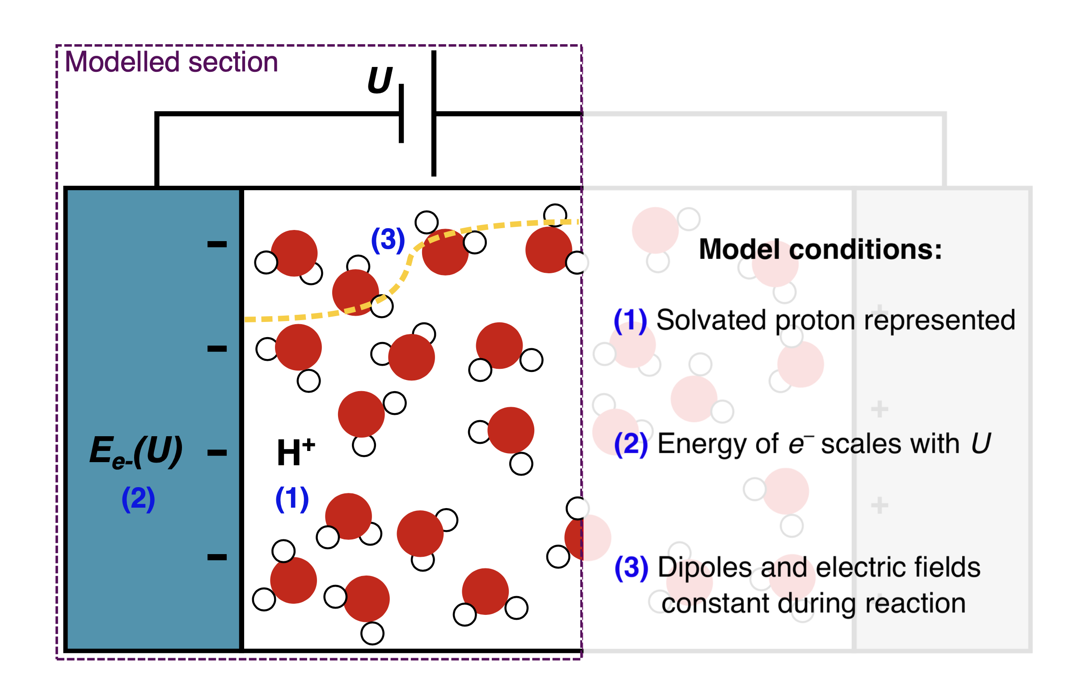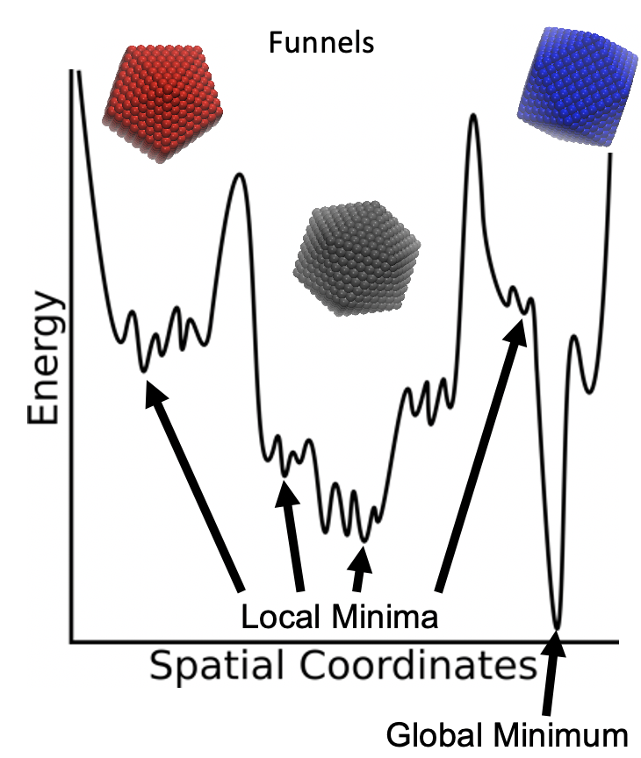

Figure: Left: Conditions required for accurate modelling of electrochemical reactions. Right: Multiple funnel potential energy landscape of nanoclusters.