**Enzyme immobilisation as a central tool in flow biocatalysis**

Sebastian C. Cosgrove

Centre for Glycoscience Research and School of Chemical & Physical Sciences, Keele University, Keele, Staffordshire, ST5 5BG

Email: [s.cosgrove@keele.ac.uk](mailto:s.cosgrove@keele.ac.uk)

**Abstract:** Enzyme immobilisation is a mature discipline, with applications ranging from the pharmaceutical industry to bioremediation.1 It is key to enabling continuous biocatalytic systems.2 Our group has applied a range of immobilised enzymes towards several flow systems, including multi-stage continuous biocatalytic cascades,3 continuous extraction and aqueous recycling systems,4 and carbohydrate acid active biocatalysts (*unpublished*).

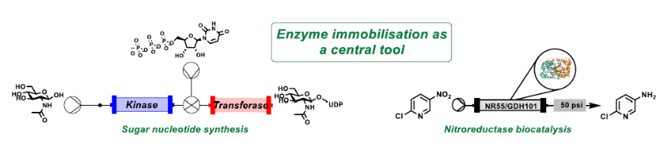

This talk will discuss some of these approaches, including multistage enzymatic reactions which are not possible under batch conditions, and how continuous reactor operations can allow for substantially improved reaction performance. It will showcase how process design and immobilisation can afford new operating windows for biocatalysis moving forward, and also discuss our effort towards designing new scaffolds for enzyme immobilisation.

**References:**

1 R. A. Sheldon and S. van Pelt, *Chem. Soc. Rev.*, 2013, 42, 6223–6235.

2 J. Britton, G. A. Weiss and J. Britton, *Chem. Soc. Rev.*, 2018, 47, 5891–5918.

3 A. P. Mattey, G. J. Ford, J. Citoler, C. Baldwin, J. R. Marshall, R. B. Palmer, M. Thompson, N. J. Turner, S. C. Cosgrove and S. L. Flitsch, *Angew. Chem. Int. Ed.*, 2021, 60, 18660–18665.

4 S. C. Cosgrove, G. J. Miller, A. Bornadel and B. Dominguez, *ACS Sustain. Chem. Eng.*, 2023, 11, 8556–8561.