Appraising the Surface Thermodynamics of Nanoscopic Liquid Drops: From a Mechanical to a Quantum Description

George JACKSON

†Department of Chemical Engineering, Imperial College London, South Kensington Campus, London SW7 2AZ, United Kingdom

e-mail: g.jackson@imperial.ac.uk

The focus of our seminar is an in-depth investigation of the mechanical and quantum features associated with the surface tension and thermodynamics of nanoscopic liquid drops. The behaviour of drops of quantum Lennard-Jones (LJ) fluids is investigated with classical Canonical Monte Carlo (MC-NVT) and with path-integral Monte Carlo (PIMC) simulations, and the test-area (TA) method [1] is used to determine the surface tension of the spherical vapour-liquid interface. As the quantum nature of the system (characterized by the de Broglie thermal wavelength, λ_{B}) becomes more significant, the average density of the liquid drop decreases, with the drop becoming mechanically unstable at large wavelengths. As a result, the surface tension is found to decrease monotonically with λ_{B}, vanishing altogether for dominant quantum interactions (Fig. 1a). The surface tension is therefore wavelength-dependent and quantum effects can be significant leading to values which are notably lower than the classical thermodynamic limit, particularly for smaller drops (Fig. 1b). Marked quantum effects are therefore unmasked for the surface thermodynamics of nanoscopic liquid drops. A significant decrease in the liquid density and surface tension is found even for weak quantum interactions. Unsurprisingly quantum effects are large in the case of the macroscopic planar interface for values of λ_{B} corresponding to hydrogen or helium at the low temperatures of vapour-liquid coexistence. Large quantum effects are, however, also found for small drops of molecules with quantum interactions corresponding to water, ethane, and carbon dioxide even at ambient conditions. The resulting reduction in the free-energy barrier of a nucleating cluster (compared to that assumed in classical nucleation theory) has important implications for the description of the nucleation kinetics of liquid drops and of bubble formation. This implies that drops would form at a much greater rate than is predicted by the classical theory [2].

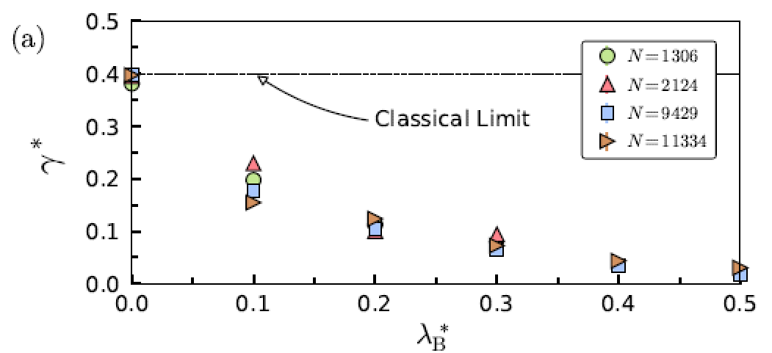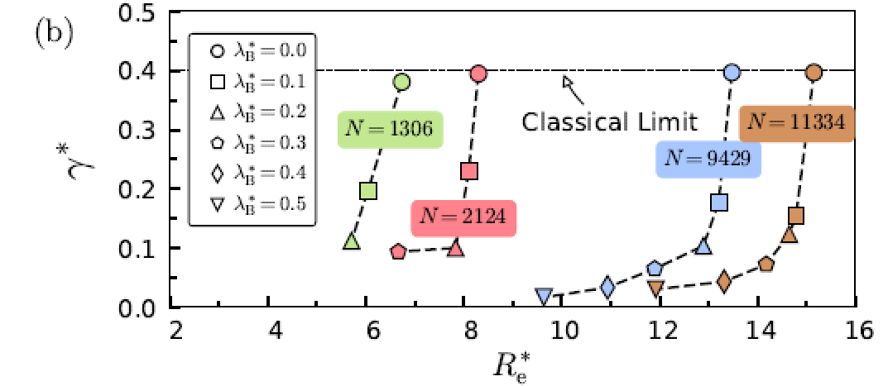
Figure 1. The (a) de Broglie wavelength λ_{B}* = λ_{B}/σ, and (b) curvature R_{e} dependence of the surface tension γ∗ = γ σ²/ε for drops of a QLJ-STS fluid with different values of λ_{B}* and number of particles N at at a temperature of T∗ = kT/ε = 0.8 obtained from PIMC simulations. The dashed lines indicate the value of γ∗ for the planar interface in the classical limit (λ_{B}* = 0), and the symbols indicate systems with different N and λ_{B}*.

[1] J. G. Sampayo, A. Malijevský, E. A. Müller, E. de Miguel, and G. Jackson, J. Chem. Phys., 132, 141101 (2010).
[2] S. Contreras, Alejandro Martínez-Borquez, C. Avendaño, A. Gil-Villegas, and G. Jackson, J. Chem. Phys., 160, 164503 (2024).

