2D semiconductors: a platform for ultrafast photonics
Giulio Cerullo
Dipartimento di Fisica, Politecnico di Milano, Piazza Leonardo da Vinci 32, 20133, Milano, Italy
Abstract

Layered materials consist of crystalline sheets with strong in-plane covalent bonds and weak van der Waals out-of-plane interactions. These materials can be easily exfoliated to a single layer, obtaining 2D materials with radically novel physico-chemical characteristics compared to their bulk counterparts. 2D semiconductors exhibit very strong light-matter interaction and exceptionally intense and ultrafast nonlinear optical response, enabling a variety of applications in optoelectronics and photonics. Furthermore, stacking 2D materials into heterostructures (HS) offers unlimited possibilities to design new materials tailored for applications
This talk will review our recent studies on the ultrafast non-equilibrium optical response of transition metal dichalcogenides (TMDs) and their HS. Using high time resolution ultrafast transient absorption (TA) spectroscopy, we monitor the ultrafast onset of exciton formation in TMDs and the dynamics of strongly coupled phonons. Using helicity resolved TA spectroscopy we time-resolve and control intravalley spin-flip processes. In HS of TMDs we time-resolve ultrafast interlayer hole transfer and interlayer exciton formation processes. We also show that strong exciton nonlinear interactions can lead to a complete quenching of the Rabi splitting in TMD-based microcavities.

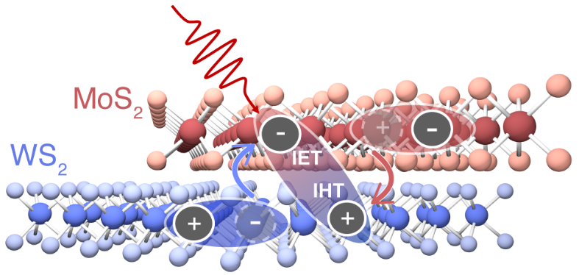
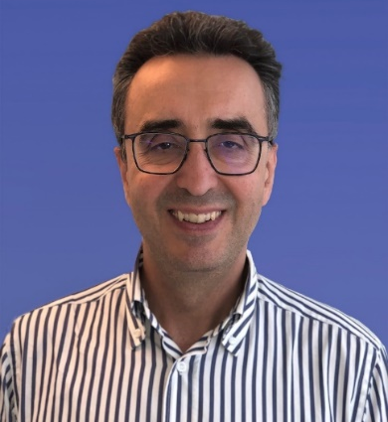
Giulio Cerullo is a Full Professor with the Physics Department, Politecnico di Milano, where he leads the Ultrafast Optical Spectroscopy laboratory, and currently a Miller Visiting Professor at UC Berkeley. Prof. Cerullo’s research activity concerns on the one hand pushing our capabilities to generate and manipulate ultrashort light pulses, and on the other hand using such pulses to capture the dynamics of ultrafast events in molecular and solid-state systems. He has published over 550 papers which have received >37000 citations (H-index: 96 on Scopus). He is a Fellow of the Optical Society of America, of the European Physical Society, of the Accademia dei Lincei and of Academia Europaea and past Chair of the Quantum Electronics and Optics Division of the European Physical Society. He has been General Chair of the conferences CLEO/Europe 2017, Ultrafast Phenomena 2018 and the International Conference on Raman Spectroscopy 2024. In 2023, he received the Quantum Electronics Prize of the European Physical Society. He is the co-founder of two spin off companies (NIREOS and Cambridge Raman Imaging).

