APACE Biannual Meeting, May 21st, Heriot-Watt University, Edinburgh

Talk 1: 14:00-14:40, LT3
Femtosecond Fieldoscopy

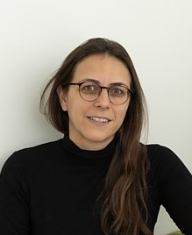
Dr. Hanieh Fattahi
Max Planck Institute for the Science of Light, D-91058 Erlangen, Germany
hanieh.fattahi@mpl.mpg.de https://www.fieldoscopy.de/

Femtosecond Fieldoscopy provides direct access to the electric field of light in ambient air, offering near-petahertz detection bandwidth together with exceptional sensitivity and a broad dynamic range. When applied to spectro-microscopy, the technique achieves attosecond temporal resolution and spatial resolution beyond the diffraction limit.
In this approach, ultrashort excitation pulses impulsively drive resonant molecular modes in a sample, initiating vibrational coherences that decay on a timescale determined by molecular dephasing. As a result, the transmitted electric field contains contributions from the excitation pulse itself, the sample’s delayed molecular response lasting several picoseconds, and a long-lived response from atmospheric gases that persists for up to hundreds of nanoseconds. By isolating and analyzing the decaying molecular field in the time domain, Femtosecond Fieldoscopy enables highly sensitive spectroscopic measurements with an exceptional dynamic range. The method has successfully resolved overtone, Raman, and combination bands in liquid samples, and recent developments have enabled super-resolution imaging well below the diffraction limit of the excitation pulses, paving the way toward non-perturbative, label-free imaging. In this talk, I will present an overview of these advances demonstrated by my group.
- S. Gommel, K. Scheffter, A. Herbst, A. Srivastava, H. Fattahi, "Photonic time stretch fieldoscopy: single-shot electric field detection at near-petahertz bandwidth," arXiv 2512.03665 (2025).
- Herbst, A. Srivastava, K. Scheffter, S. Jun, S. Gommel, L. Rebecchi, S. Kuriyil, A. Rubino, N. Petrini, I. Kriegel, H. Fattahi, "Ultrafast nonlinear dynamics of indium tin oxide nanocrystals probed via fieldoscopy," Advanced Science (2025).
- A. Srivastava, A. Herbst, M. M. Bidhendi, M. Kieker, F. Tani, H. Fattahi, "Near-Petahertz Fieldoscopy of Liquid," Nature Photonics (2024).
- A. Herbst, K. Scheffter, M. M. Bidhendi, M. Kieker, A. Srivastava, H. Fattahi, "Recent advances in petahertz electric field sampling," Journal of Physics B, 55, 172001 (2022).

Break with Coffee and Tea: 14:40-15:00

Talk 2: 15:00-15:40, LT3
Organic Semiconductor Optoelectronics: From OLEDs to Lasers
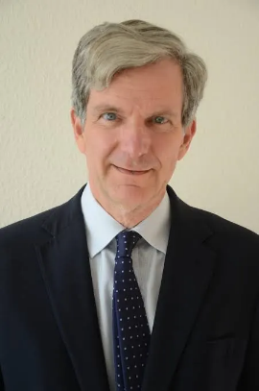

Prof. Ifor D.W. Samuel FRSE
Organic Semiconductor Centre, SUPA, School of Physics and Astronomy, University of St Andrews, St Andrews, UK
idws@st-andrews.ac.uk
https://polyopto.wp.st-andrews.ac.uk/

Organic semiconductors are remarkable carbon-based materials that combine novel semiconducting optoelectronic properties with simple processing. They can be used to make printed and flexible electronics, and their properties (e.g. colour) can be tuned by changing their chemical structure. Organic light-emitting diodes (OLEDs) are compact visible light sources that are now found across the world in mobile phone displays and televisions. This talk will give an introduction to organic semiconductors, optoelectronic devices made from them and briefly show applications in communications and medicine.

It will then explore the development of organic semiconductor lasers. For decades these lasers have required optical pumping by another laser. The journey towards practical organic semiconductor lasers has required advances in optical design to reduce threshold and enable smaller pump sources. Finally, a new organic optoelectronic device – a laser electrically driven by an OLED will be presented.

