**Photonics in disordered environments and fibre based imaging**

Tomáš Čižmár

*University of Dundee, Nethergate, Dundee DD1 4HN, United Kingdom*

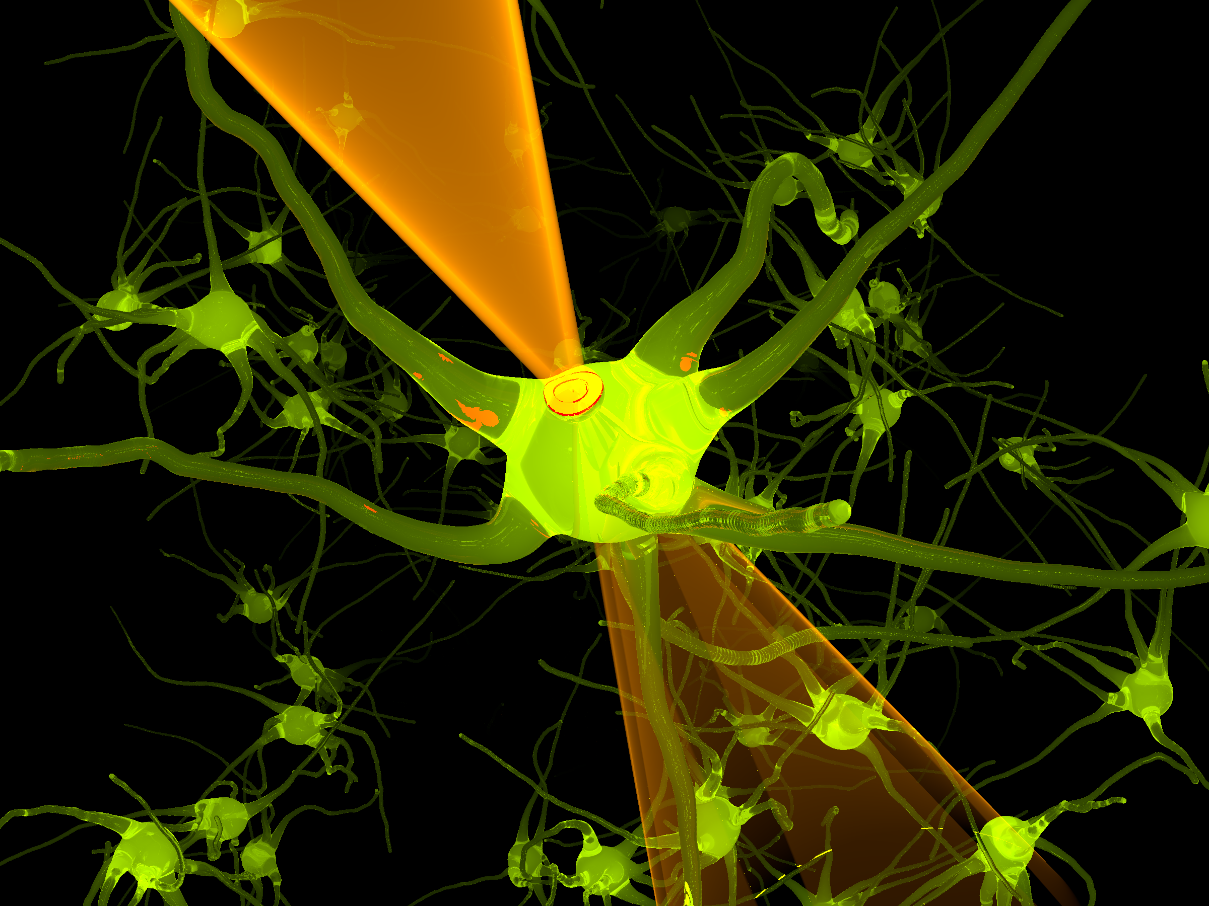Astronomical observations from ground-based telescopes are degraded by the random and rapidly varying distribution of refractive index in the Earth’s atmosphere. Similarly, in Biology and Medicine, imaging of tissues and living organisms at visible wavelengths is limited by the highly scattering and absorbing nature of these environments; image quality and maximum image depth are both reduced by these conditions.

Optogenetics is one of the rapidly evolving modern disciplines that would particularly benefit from the possibility to provide the optimal performance of imaging devices and bio-photonics techniques *in vivo*.

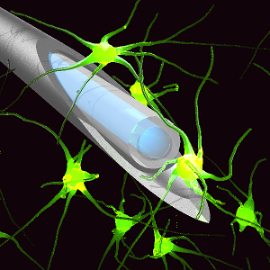Novel holography-based strategies to correct these unwanted deviations from the ideal wavefront and thereby redeem the optimal performance of bio-photonic systems in such turbid media will be discussed in the lecture. In addition to their high Bio-Medical relevance, these methods represent a powerful approach towards full understanding of laser light propagation through any randomizing system.

An important example of this is light transmission within a multimode optical fibre. Coherent light propagating through such waveguide is randomized but the image information is not lost and can be decoded once the overall response of the system is measured. The possibility of converting the random output signal into a diffraction limited focus, as well as any other light shapes, will be discussed together with a number of applications including optical manipulation and imaging.

1. In situ wavefront correction and its application to micromanipulation. Čižmár, T., Mazilu, M. & Dholakia, K. Nature Photonics 4 388-394 (2010).
2. Shaping the light transmission through a multimode optical fibre: complex transformation analysis and applications in biophotonics. Čižmár, T. & Dholakia, K. Optics Express 19(20) 18871-18884 (2011).
3. Shaping the future of manipulation. Dholakia, K. & Čižmár, T. Nature Photonics. 5 335-342 (2011)
4. Exploiting multimode waveguides for pure ﬁbre based imaging. Čižmár, T. & Dholakia, K. Nature Communications (2012).