CH₃NH₃PbI₃ Perovskite Solar Cells using CuSCN Inorganic Hole Transmitting Layer
Seigo Ito
Department of Electrical Engineering and Computer Sciences,Graduate School of Engineering, University of Hyogo. 2167 Shosha, Himeji, Hyogo, 671-2280 JAPAN.
Email: itou@eng.u-hyogo.ac.jp
Despite the rapid increase in efficiency of the hybrid organic-inorganic methylammonium lead halide perovskites (CH₃NH₃PbI₃, X = Cl-, Br-, I-) solar cells, the hole transporting material (HTM) used were mainly limited to organic compounds, the start-of-the-art 2,2’,7,7’-tetrakis(N,N-di-p-methoxyphenylamine)-9,9’-spirobifluorene (spiro-MeOTAD) and conducting polymers. Compared to organic HTMs, inorganic p-type semiconductors appear to be an ideal choice from the point of view of high mobility, stability ease of synthesis and low cost. Here, we report that combining the perovskite CH₃NH₃PbI₃ with CuSCN as p-type HTM lead to solar cells with very high power conversion efficiency (12.4%) under full sun illumination (Fig. 1). Moreover, to improve the stability, Sb₂S₃ layers were inserted at the interface between TiO₂ and CH₃NH₃PbI₃ perovskite to be CH₃NH₃PbI₃ solar cells using inorganic hole transporting material (CuSCN) (Fig. 2). The CH₃NH₃PbI₃ layer was spin-coated by one-drop method on nanocrystalline TiO₂ layer. During the light exposure test without encapsulation, the CH₃NH₃PbI₃ solar cells without Sb₂S₃ deteriorated to zero efficiency in 12 h and were completely changed from black to yellow, because the perovskite CH₃NH₃PbI₃ was changed to hexagonal PbI₂. With Sb₂S₃, on the other hand, the CH₃NH₃PbI₃ solar cells became stable against light exposure without encapsulation, which didn’t change the crystal structure and the wavelength edges of absorption and IPCE. Therefore, it was considered that the degradation can occur at the interface between TiO₂ and CH₃NH₃PbI₃.
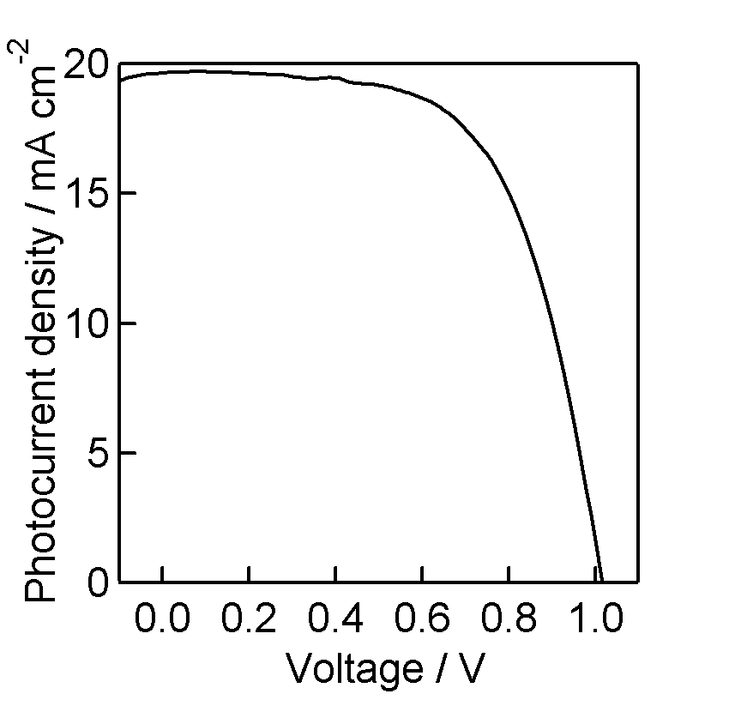
Fig. 1. Photo current density-voltage curve of CH₃NH₃PbI₃ perovskite solar cells using CuSCN hole-transporting material.
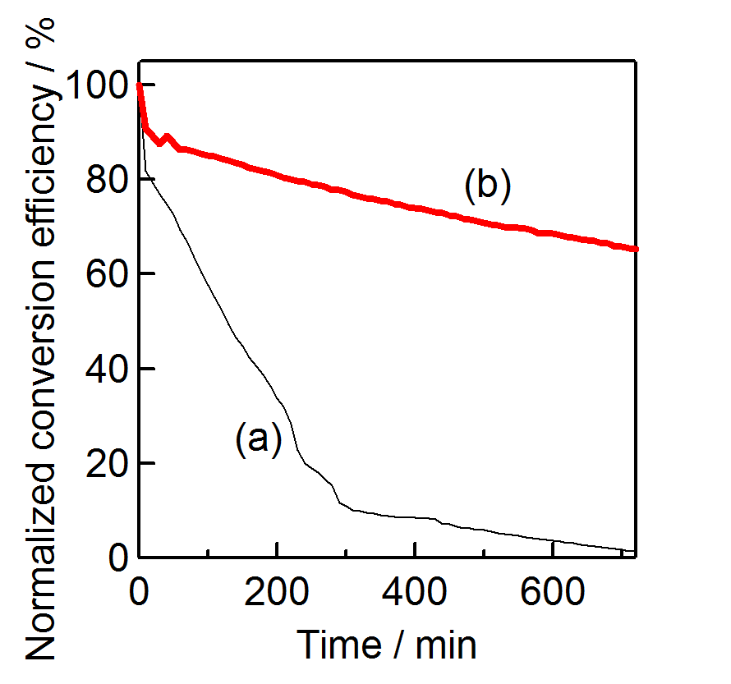
Fig. 2. Variation of photoenergy conversion efficiencies of solar cells during light exposure (AM1.5, 100 mW cm-2) without encapsulation in air for 12 hours: (a) <FTO/TiO₂/CH₃NH₃PbI₃/CuSCN/Au>; (b) <FTO/TiO₂/Sb₂S₃/ CH₃NH₃PbI₃/ CuSCN/Au>.

Fig. 2. Variation of photoenergy conversion efficiencies of solar cells during light exposure (AM1.5, 100 mW cm-2) without encapsulation in air for 12 hours: (a) <FTO/TiO₂/CH₃NH₃PbI₃/CuSCN/Au>; (b) <FTO/TiO₂/Sb₂S₃/ CH₃NH₃PbI₃/ CuSCN/Au>.
Fig. 2. Variation of photoenergy conversion efficiencies of solar cells during light exposure (AM1.5, 100 mW cm-2) without encapsulation in air for 12 hours: (a) <FTO/TiO₂/CH₃NH₃PbI₃/CuSCN/Au>; (b) <FTO/TiO₂/Sb₂S₃/ CH₃NH₃PbI₃/ CuSCN/Au>.
Fig. 2. Variation of photoenergy conversion efficiencies of solar cells during light exposure (AM1.5, 100 mW cm-2) without encapsulation in air for 12 hours: (a) <FTO/TiO₂/CH₃NH₃PbI₃/CuSCN/Au>; (b) <FTO/TiO₂/Sb₂S₃/ CH₃NH₃PbI₃/ CuSCN/Au>.
Fig. 2. Variation of photoenergy conversion efficiencies of solar cells during light exposure (AM1.5, 100 mW cm-2) without encapsulation in air for 12 hours: (a) <FTO/TiO₂/CH₃NH₃PbI₃/CuSCN/Au>; (b) <FTO/TiO₂/Sb₂S₃/ CH₃NH₃PbI₃/ CuSCN/Au>.
Fig. 1. Photo current density-voltage curve of CH₃NH₃PbI₃ perovskite solar cells using CuSCN hole-transporting material.
Fig. 1. Photo current density-voltage curve of CH₃NH₃PbI₃ perovskite solar cells using CuSCN hole-transporting material.

