**New Molecular Tracers for the PET and SPECT Imaging of Disease**

Andrew Sutherland

WestCHEM, School of Chemistry, The Joseph Black Building, University of Glasgow,

Glasgow, G12 8QQ, UK. Email: Andrew.Sutherland@glasgow.ac.uk.

In the last two decades, the radionuclide techniques of positron emission tomography (PET) and single photon emission computed tomography (SPECT) have had a significant impact on many aspects of healthcare.1 They are used routinely for the diagnosis and prognosis of many diseases and are involved in various stages of drug development. With an ageing population, new molecular tracers and radiopharmaceuticals have the potential to play a key role in understanding age-related illnesses such as cancer, heart disease and dementia. However, a number of limitations associated with these technologies still exist, including the discovery of new imaging agents that can bind with high affinity and specificity to key biological targets and the development of novel, non-toxic and efficient methods for the preparation of PET and SPECT imaging agents.

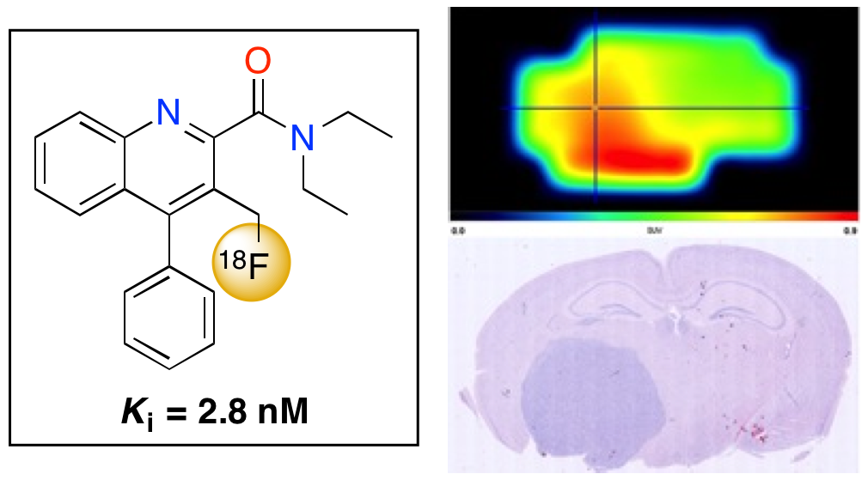 Over the last ten years, our research has focused on overcoming some of these limitations, leading to new imaging agents for diseases associated with neurology and oncology. This seminar will give an overview of some of these developments, including a new SPECT imaging agent of the noradrenaline transporter and a novel PET imaging agent that can detect brain tumours (see figure).2,3 The presentation will also describe new transition metal catalysed methods that have been developed for the rapid preparation of iodinated and radioiodinated compounds for SPECT imaging. For example, we have developed a one-step nickel(0)-catalysed iodination of aryl and heteroaryl bromides that is general for a wide range of highly functional substrates.4 With some optimisation this procedure was extended for the direct and highly efficient radioiodination of aryl bromides.5 An application of this procedure in diagnostic imaging was demonstrated with the preparation of 5-[123I]-A85380, a SPECT tracer used for imaging neuronal nicotinic acetylcholine receptors in humans. More recently, other metal-catalysed reactions have been investigated for generating iodinated and radioiodinated aryl compounds including the iron(III)-catalysed iodination of electron rich arenes with *N*-iodosuccinimide.6 An overview of the key developments of these new transformations will also be described.

1. S. L. Pimlott and A. Sutherland, *Chem. Soc. Rev.*, 2011, **40**, 149.

2. N. K. Jobson, A. R. Crawford, D. Dewar, S. L. Pimlott and A. Sutherland, *Bioorg. Med. Chem. Lett*., 2009, **19**, 4996.

3. A. Blair, F. Zmuda, G. Malviya, A. A. S. Tavares, G. D. Tamagnan, A. J. Chalmers, D. Dewar, S. L. Pimlott and A. Sutherland, *Chem. Sci*., 2015, **6**, 4772.

4. A. A. Cant, R. Bhalla, S. L. Pimlott and A. Sutherland, *Chem. Commun*. 2012, **48**, 3993.

5. A. A. Cant, S. Champion, R. Bhalla, S. L. Pimlott and A. Sutherland, *Angew. Chem. Int. Ed*., 2013, **52**, 7829.

6. D. T. Racys, C. E. Warrilow, S. L. Pimlott and A. Sutherland, *Org. Lett*., 2015, **17**, 4782.