**Porous Organic Cages: More than MOFs Minus the Metals?**

Andrew I. Cooper, University of Liverpool, UK

Porous molecular crystals are an alternative to porous extended frameworks such as zeolites, metal-organic frameworks (MOFs), covalent organic frameworks (COFs), and microporous polymer networks. Interest in such systems dates back to Barrer’s ‘organic zeolites’,1 but only recently have these materials started to show properties of potential practical interest.2   
One distinguishing property of molecular materials is their solubility: unlike extended frameworks, molecular crystals can be processed in solution into a variety of formats.3 They can also show unique physical properties, such as reversible on/off porosity switching4 and perfect shape selectivity for organic isomers.5

However, molecular crystals also raise challenges in terms of the purposeful design of solid-state function.6 This is because the energy landscape for molecular crystals is often not dominated by a single intermolecular interaction, unlike bonded crystalline frameworks such as MOFs and covalent organic frameworks. Hence, molecular crystal engineering has so far failed to become the “new organic synthesis” that has been envisaged.7

This lecture will discuss strategies for the design and synthesis of new functional organic crystals by using a mixture of computation8,9 and intuitive design, the latter based on tecton assembly rules.10 We will exemplify this with recent examples of function in real porous molecular solids, such as selectivity for rare gas separations,11 which was targeted using computation. We will discuss whether or not *in silico* ‘design’ can compete currently with iterative synthesis and measurement for crystalline organic materials.

We will also present new work where we access new states of matter that cannot be achieved using frameworks, such as the first generation of ‘porous liquids’.12

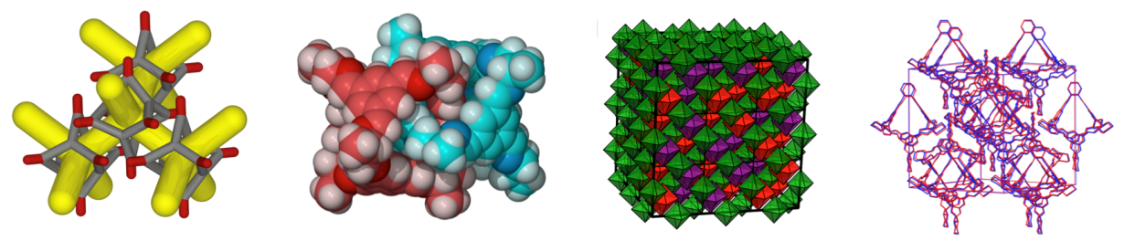

1. Barrer, R. M.; Shanson, V. H. *J. Chem. Soc., Chem. Commun.* **1976**, 333.
2. (a) Mastalerz, M.; Oppel, I. M. *Angew. Chem., Int. Ed.* **2012**, *51*, 5252; (b) Liu, M. *et al.*, *J. Am. Chem. Soc.*, **2014**, DOI: 10.1021/ja503223j.
3. (a) Bushell, A. F. *et al.*, *Angew. Chem., Int. Ed.* **2013**, *52*, 1253; (b) Hasell, T. *et al.*,   
   *J. Am. Chem. Soc.* **2012**, *134*, 588.
4. Jones, J. T. A. *et al.*, *Angew. Chem., Int. Ed.* **2011**, *50*, 749.
5. Mitra, T., *et al.*, *Nat. Chem.*, **2013**, *5*, 247.
6. Jansen, M.; Schön, J. C. *Angew. Chem., Int. Ed.* **2006**, *45*, 3406.
7. Desiraju, G. R. *Angew. Chem., Int. Ed.* **1995**, *34*, 2311.
8. Jones, J. T. A., *et al.*, *Nature* **2011**, *474*, 367.
9. Jiang, S., et al., *J. Am. Chem. Soc.*, **2013**, *135*, 17818.
10. Hasell, T., *et al.*, *J. Am. Chem. Soc.*, **2014**, *136*, 1438.
11. Chen, L., *et al.*, **2014**, *in revision*.
12. Greenaway, R., *et al.*, *unpublished results*.

We thank EPSRC (EP/H000925/1 & EP/K018396/1) and the European Research Council (project RobOT) for funding.