Electronic structure calculations have long contributed to the understanding of the function of nano-structured materials and have increasingly reached predictive accuracy in the development of such materials, as exemplified by the materials genome project. We present work on OLED (organic light emitting diode), twisted bilayer graphene and two-dimensional perovskites.

Transport through thin organic amorphous films, such as those used in OLED and OPV devices, has been difficult to model using first-principles methods. One of the main reasons comes from the fact that carrier mobility depends strongly on the disorder strength and reorganization energy, both of which are significantly affected by the environment of each molecule, making typical system sizes to model a challenge even for most modern and optimal approaches. Here, we present a multi-scale approach to model carrier mobility, Fig. 1. We apply this strategy to compute the carrier mobility for a set of widely studied molecules and obtain good agreement between experiment and theory. Further, we use the method to demonstrate in silico materials design.

Graphene-based materials have long been considered as promising for a new generation of high-frequency (terahertz) electronic devices. As an application of molecular building blocks, we will discuss effects of intercalation on electronic structure of twisted graphene bilayers. A discussion on how the choice of twist angle and intercalant can be utilized for bandgap opening will be presented too.

Perovskites are intensely investigated for energy conversion applications. We have investigated two closely related 2D layered hybrid perovskite-like bromoplumbates, with very different emission properties, both experimentally and theoretically. By means of electronic structure calculations point defects, more specifically extrinsic charge self-trapping at point defect sites, were potentially identified as the source of disparate emission characteristics.

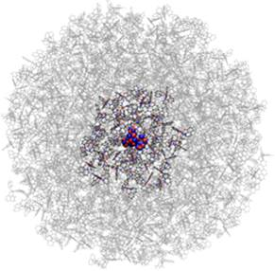

*Figure 1. A graphical representation of an effective embedding of Tris-(8-hydroxyquinoline)aluminium (Alq3) molecule in disordered matrix. Alq3 is a standard Electron Transport Layer (ETL) material in OLED devices.*