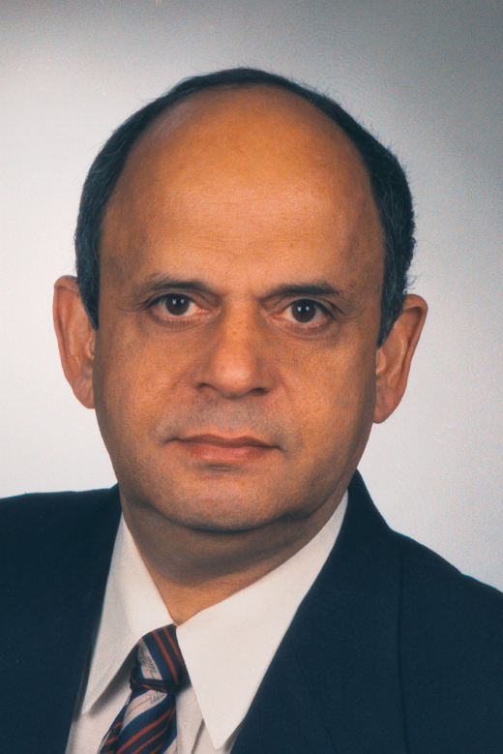

Bodh Raj Mehta is currently Professor of Physics and Schlumberger Chair professor of Semiconductor Physics at Indian Institute of Technology Delhi, New Delhi, India. He did his M Sc in Physics from Punjabi University Patiala, M Tech in Solid State Materials and Ph D in Physics from IIT Delhi. He has worked as post-doctoral fellow at University of British Columbia, Canada; guest scientist at University of Saarbrucken, Germany; and guest professor at University of Duisburg, Germany. He has about 25 years experience in teaching and research. His major research interests are; Science and Technology of Thin Films and Nanostructured Materials for Solar Cell, Resistive Memory, Thermoelectric and Gas Sensor Devices. He is the recipient of MRSI Medal (Material Research Society of India, 2002), DAAD Fellowship (Deutscher Akademischer Austausch Dienst, 2000) and Marie Curie International Fellowship (European Commission, 2006). He is on the Editorial Board of Journal of Nanoscience and Nanotechnology and has about 160 journal publications. He is the Coordinator of the ‘Unit on NanoScience’ (Nanomission) at IIT Delhi; Co-coordinator of Nano Research Facility at IIT Delhi. One of his projects ‘NanoSwitch’ has been selected by European Commission as a ‘Success Story’ project.

